File system:
In Linux, "everything is a file." A file system is the underlying structure that manages how data is stored, organized, and retrieved from physical or virtual storage devices.
Unlike Windows (which assigns drive letters like C: or D:), Linux organizes all drives and partitions into a single, unified directory tree starting at the Root Directory (/).
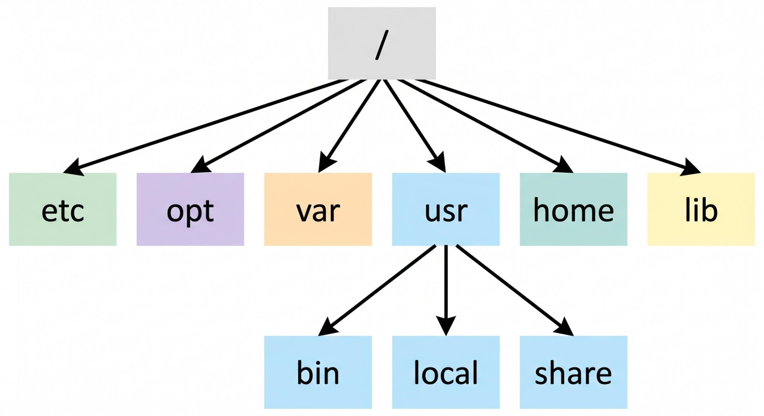

1. The Directory Structure (FHS)
The Filesystem Hierarchy Standard (FHS) defines where files and directories should reside across Linux distributions:
Directory | Purpose
/ | Root: The top-level starting point of the entire file system hierarchy.
/bin & /sbin | Essential user binaries (ls, cp) and administrator binaries (fdisk, iptables).
/etc | System-wide configuration files (e.g., /etc/fstab, /etc/nginx).
/home | Personal directories for standard users (e.g., /home/alex/).
/var | Variable data that changes continuously (system logs, databases, mail spools).
/usr | Multi-user utilities, applications, and shared libraries (/usr/bin).
/dev | Device files representing hardware components (e.g., /dev/sda for storage disks).
/proc & /sys | Virtual file systems generated in RAM exposing live kernel and process data.
/tmp | Temporary storage files, typically cleared upon system reboot.

2. Core Architectural Concepts

Inodes (Index Nodes)
In Linux, a filename is simply a human-friendly label linked to an Inode. An inode stores all metadata about a file—except its name and actual content:
- File size and physical disk block locations
- Permissions (Read, Write, Execute) and ownership (UID/GID)
- Timestamps (atime access, mtime modification, ctime status change)
- Hard link count
Tip: Running out of inodes prevents you from creating new files—even if your disk has hundreds of gigabytes of free space available.

Virtual File System (VFS)
The VFS is an abstraction layer in the kernel. It allows applications to use uniform system calls (read(), write(), open()) regardless of whether the storage underlying it is Ext4, XFS, FAT32, or a remote network drive (NFS).

Journaling
Modern Linux file systems use journaling to prevent data corruption. Changes are recorded in a small log (the journal) before being committed to the main storage area. In the event of a sudden crash or power failure, the file system reads the journal to quickly restore consistency without running a full disk scan (fsck).

3. Popular Linux File System Types
File System | Key Characteristics | Best Use Case
Ext4 | Mature, rock-solid, fast journaling filesystem. Default for Debian, Ubuntu, and Linux Mint. | Desktop PCs, virtual machines, and standard servers.
XFS | High-performance, highly scalable filesystem designed for large files and parallel I/O. | Enterprise servers, big data clusters, and default for RHEL.
Btrfs | Copy-on-Write (CoW) filesystem with native RAID support, instant snapshots, and self-healing. | Fedora desktop default, advanced NAS setups, and workstations.
ZFS | Enterprise-grade CoW file system combining pooled volume management, compression, and snapshotting. | Storage servers, FreeBSD/Linux hypervisors, heavy-duty NAS.
tmpfs | In-memory (RAM) filesystem for lightning-fast, non-persistent storage. | Temporary caches, /tmp mounts, high-speed RAM disks.

The OSI Model
The OSI (Open Systems Interconnection) model is a conceptual framework that standardizes how different networking systems communicate. It breaks the process of network communication into 7 layers, each handling a specific function. Data passes down through these layers on the sending device and back up through them on the receiving device.

The 7 Layers (top to bottom)
7. Application Layer
- Closest to the end user
- Provides network services directly to applications (browsers, email clients, etc.)
- Examples: HTTP, FTP, SMTP, DNS
6. Presentation Layer
- Translates, encrypts, and compresses data
- Ensures data is in a usable format for the application layer
- Handles things like SSL/TLS encryption, data formatting (JPEG, ASCII, etc.)
5. Session Layer
- Manages sessions/connections between applications
- Establishes, maintains, and terminates communication sessions
- Handles things like authentication and reconnection
4. Transport Layer
- Ensures complete, reliable data transfer between systems
- Handles segmentation, flow control, and error checking
- Key protocols: TCP (reliable, connection-oriented) and UDP (fast, connectionless)
3. Network Layer
- Handles logical addressing and routing between different networks
- Determines the best path for data to travel
- Key protocol: IP (Internet Protocol); devices: routers
2. Data Link Layer
- Handles physical addressing (MAC addresses) and node-to-node data transfer within the same network
- Detects and corrects errors from the physical layer
- Devices: switches, network interface cards (NICs)
1. Physical Layer
- The actual physical medium — cables, radio waves, electrical signals
- Transmits raw bits (0s and 1s)
- Devices: hubs, cables, connectors

A Simple Way to Remember (top to bottom)
All People Seem To Need Data Processing (Application, Presentation, Session, Transport, Network, Data Link, Physical)

Why It Matters
- Standardization: Different vendors' hardware/software can interoperate because they follow the same layered structure.
- Troubleshooting: If there's a network issue, you can isolate the problem to a specific layer (e.g., "Can I ping the IP?" → Layer 3 issue).
- Modularity: Changes in one layer (e.g., switching from Wi-Fi to Ethernet at the Physical layer) don't require changes in other layers.

OSI vs. TCP/IP Model
In practice, the internet runs on the simpler TCP/IP model (4 layers: Application, Transport, Internet, Network Access), which maps roughly onto OSI but combines several layers together. OSI is mostly used today as a teaching and reference tool rather than something literally implemented layer-by-layer.
Want me to go deeper into any particular layer, or explain how data encapsulation works as it moves through the layers?

